Nepal College of information Technology
Imado lalitpur
Assessment Exam Spring Semester 2007

Program : ELX Semester: Spring
Time : 3hrs Year : 2007
Digital Signal Processing
Attempt all the questions

1 (a) Describe the basic elements of a typical digital signal processing system. [7]
(b) Test linearity, time-invariance, causality and stability of the following system:
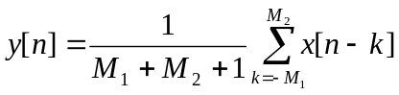 [2*4]

2 (a) Define LTI system and convolution. Derive an expression to relate input and output of a linear-time variant system. [2+5]
(b) An input-output relationship of a LTI system is defined as:
y[n]- 2y[n-1]=3x[n]+x[n-1]-2x[n-2]
Find the impulse response h[n] of the system. Also sketch h [2n]. [Hint: Do not use z-transform.] [6+2]

3. (a) Determine the inverse z-transform of 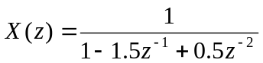 for ROC: 0.5<|z|<1
[Hint: Use partial fraction.] [7]
(b) Let x[n] be a sequence with z-transform X (z). Then, determine the z-transform of x[-n]. [8]

4. (a) Determine the computational complexity of direct computation of DFT and compare it with that of Radix-2 algorithm with suitable example. [5]
(b) Determine the 4-point DFT of x[n]={1,2,3} using any FFT algorithm. [5]
(c) List out some practical applications of DFT/FFT. [5]

5 (a) Draw the lattice-ladder structure for the following system function:
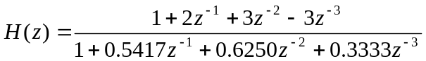
[10]
(b) Obtain direct form II structure of a system defined as:
y[n]-y[n-2]=x[n]+1.503x[n-1]-0.5x[n-2]-x[n-3]
[5]
6. (a) List out some advantages of digital signal processing as compared to analog signal processing. [7]
(b) Find the circular convolution of x₁[n]={2,1,2,1} and x₂[n]={1,2,3,4}. [8]
7. Write short notes on (any two) [2*5]
(i) Stability of discrete time system
(ii) Relation between z-transform and DFT
(iii) Relationship between causality and ROC
(iv) Nyquist sampling criteria with suitable example

